Access to Employment

The goal of this program is to provide targeted trainings for the under and/or unemployed so they are prepared to fill specifically identified job openings in the region. Access to Employment does this by identifying gaps and barriers and then working to close those gaps and barriers in collaboration with agencies, employers and funders. Working together to keep people successfully employed.
  - Community Plan
  - 8-22-16

Access to Employment
Community Plan
8-22-16

Contents:

Introduction
Access Community Action Agency - history and mission
Access to Employment (A2E) - history and mission

Access to Employment Collaborative and Advisory Team
Members
A2EC
A2EAT
Explanation of Process
Member organizations
Meeting Structure

Access to Employment Job Seeker and Industry Sectors
Explanation and Identification

Access to Employment Program – Barriers and Training
Barriers
Transportation
Financial Literacy
Computer Literacy
Motivation
Recognition of barriers
Training
Programs and Case Management
Community Connection

Access to Employment – Future Goals and Sustainability
Future
Sustainability
Budget

Closing Remarks

Introduction
The Access Community Action Agency began in 1965 as the Windham Area Community Action Program, Inc. and born from the nation’s “war on poverty.” Today, 51 years later, it is the Community Action Agency for Windham and Tolland Counties and known as Access Community Action Agency. The Access mission is “to create opportunities that empower people and communities to achieve and sustain economic stability.” For 51 years Access has been working in community to create affordable housing, provide fuel assistance, and help families in need with food, education, nutrition and other basic services; all with the goal of economic stability. It only made sense that when the United Way of Central and Northeastern CT (UW) came looking for an agency east of the river to create a plan for employment services they would choose Access Community Action Agency. This choice lead to the creation of Access to Employment or A2E.

Access provides case management to individuals and families in order to better coordinate their usage of all of its programs. It was this aspect of the agency that attracted the UW to Access. The United Way, after a comprehensive strategic review, decided to fund employment initiatives as part of its new mission. Coming to the NE corner of the state made sense, as Tolland and Windham Counties rank among the highest in unemployment in the state. Choosing the Access Agency to take the lead on the planning project also made sense due to its history of case management in so many areas of wellbeing. Willimantic was chosen as the target city for the planning project and the Access agency hired a planner to assemble the collaborative and develop this plan.

The criteria for choosing members of the collaborative were based on the desire to have a full choir of voices contributing to the plan. People who represented sector employment, both private and public; business owners, agency employees and HR directors, employers both large and small, as well as policy makers, public officials and municipal employees, funders and educators, were all important members of the final collaborative and advisory team. The initial job of the program planner was to meet with individuals, discuss the gaps and barriers they faced, and then to ask if they wanted to be part of a collaborative of people who, while meeting for only a short time (these are by-and-large very busy people), would be charged with a substantial amount of work. The response was overwhelmingly positive. Very quickly a working collaborative was formed, along with an advisory team, respectively: Access to Employment Collaborative (A2EC) and Access to Employment Advisory Team (A2EAT).

The Collaboration – Access to Employment Collaborative and the Advisory Team

Before Access to Employment can become a program, it was a conversation initiated, shaped and honed by a collection of people. These people became the Access to Employment Collaborative and Advisory Team. Employers, policy makers, funders, educators and other community leaders who had been shaping the direction of Willimantic’s underemployed via their own initiatives and agency goals for many years were asked to give their time and expertise to the effort. People were asked to commit to either the intensive work of the collaborative or to serve in an advisory role. The following people graciously agreed to meet and/or inform A2E and the community plan.

Access to Employment Collaborative

Municipal
Jim Bellano – Chair, Town of Windham
Maggie Ferron, JD - Town of Mansfield

Employers
Chris McNaboe – Horizons, Inc.
Simon Wells – Horizons, Inc.
Tom DeVivo – Willimantic Waste/Windham Town Council
Pat Duffy – St. Joseph’s Living Center
Sue Robarge – Columbia Ford/Gates GMC
Kylee Carbone - Westminster Tool

Funders
Sue Murphy- Liberty Bank Foundation
Ricardo Henriquez – United Way of Central and Northeastern CT

Education
Cherie Poirier -Eastern CT Area Health Education Center
Mariceli Rojas –Windham Public Schools

Business Entrepreneur
Benjamin Williams – Innovative Diffusion

Access to Employment Advisory Team
Heather Meehan – Meehan and Daughters, Realtors
Steve LaPointe – Quinebaug Valley Community College Manufacturing
Jodi Clark – Quinebaug Valley Community College Manufacturing
Diane Nadeau – Windham Region Chamber of Commerce
Linda Riquier – American Jobs Center/Quinebaug Valley Community College
Rich Tariff – EASTCONN
William Clark – Workforce Solutions
Jackie Petrizzo – Savings Institute Foundation
Shawn Maynard – Windham Hospital at Hartford Healthcare
The Collaborative met twice a month for several months to ask the questions and deliberate the answers so as to inform the work of the planner and ultimately the Community Plan. Many of the members also met one-on-one or in smaller work groups to move the information along. Member’s also researched information, invited the program planner to “member only” meetings, and facilitated learning for the group at-large in areas of industry specific information.

The A2E Advisory Team agreed to be “on speed dial” and were invited to and informed on all A2EC meetings. While not involved in the nut and bolts of the collaborative, many A2EAT members were instrumental in the planning process.

Along with individuals, the A2E plan is aided by organizations and their representatives. Many agencies and organization are involved in working with people on a variety of issues that prevent them from being successfully employed. To understand all of the possible barriers, A2E sough the counsel of the following agencies, programs, institution and organizations thru their respective representatives.

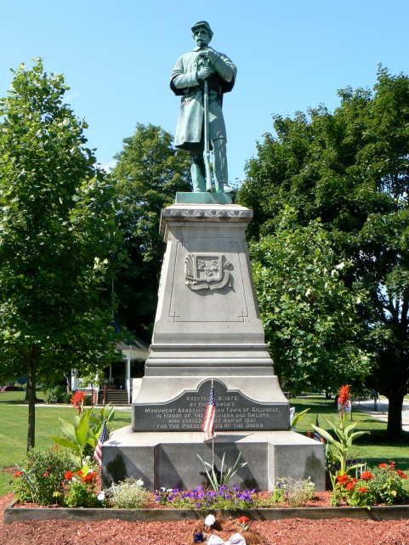
Business/Employers
Hosmer Mountain Soda – Bill Potvin
Gates GMC/Nissan and Gates University -Denny Gates
Pride’s Corner Farm - Mark Sellew
Frito-Lay – Erik Sanborn
Main St. Café/Willi Brew Pub – Dave Wolner
Willimantic Food Coop – Alice Rubin
NE Federal Family Credit Union – Joanne Todd

Educational Institutions
Quinebaug Valley Community College – Katie Gregory
Windham Public Schools – Bill Stover, Joylene Albaracine, Nusie Halpin
Eastern CT State University – Clifford Marrotte

Agencies and Organizations
Access Community Action Agency – Karen Adamson
Perception Programs Inc. – Ruth Gordon
Eastern Workforce Investment Board – Carol LaBelle, Virginia Sampietro
Windham No Freeze Hospitality Center – Leigh Duffy
Eastern CT Transportation Consortium – John Roode
CLiCK – Rachel LaPorte
United Services – Melissa Garrett
Taste of the Town – Maureen Crowley
Eastern Advanced Manufacturing Alliance – Kylee Carbone
CT Employment and Training Commission/CT Construction Industries Assoc. – Don Shubert

Programs
Windham Public Schools ECO – Vanessa Sousa, Kristin Negron
Climb the Ladder to a Better Future – Liz Smith (Access)
Women Inspired – Eva Csejtey (Access)
Workforce Solutions - William Clark
Summer Youth Employment/Cool Directions – Cyndi Wells (EASTCONN)
Job Development – Vicky Meyer (EASTCONN)
Windham Heights Learning Center – Mercedes Arroyo

Funders
Ossen Family Foundation – Eileen Ossen, Carol Williams
Verizon Wireless Zone Foundation – Scott Gladstone
Community Foundation of Eastern CT - Lillian Rhodes
Department of Economic and Community Development, State of CT – Gregory Lewis
First Niagara Foundation
Charter Oak Credit Union

Beginning in March of 2016, the A2E Collaborative began meeting twice monthly to discuss the barriers and gaps the employers reported were preventing them from successfully keeping a workforce continuously employed. Identifying area sector employment and the unique needs of each sector was a large part of the A2EC process, as well as identifying existing services, funding sources, and what the greater Willimantic community was doing well to help support both employers and job seekers. A decision was made at the beginning of the process not to replicate existing services if those services were strongly in place and helping jobseekers and employers to stay successful.

By June the Collaborative decided to meet once a month, and in July the plan, as written by the planner, was given to the A2EC for approval. This document, the Access to Employment Community Plan, represents the five months of investigation, education, review and revision of the Access to Employment Program by the Access to Employment Collaborative.

Access to Employment Job Seeker and Industry Sectors

The A2E job seeker is identified as a person of at least 18 years of age with the base line education of a GED. The Collaborative recognized that there are job seekers in the greater Willimantic community who do not have that level of education and may not yet be 18 years of age, but felt for a variety of reasons that this base line was where this program should begin. Job seekers are under- or unemployed and are looking to enter the labor market somewhere in the minimum wage ($9.60/hr.) to $15/hr. category. Both men and women of all ethnic and racial backgrounds and without an age limit are included in the A2E program profile. Job seekers who do not meet the minimum educational requirements can be assisted by A2E by directing them to GED and equivalent programs that are offered by other local agencies such as EASTCONN. Job seekers who qualify for a higher wage/hour job (based on education and other qualifications) will be directed to the American Jobs Center or other agencies that can assist with relevant services. Job seekers who identify as having barriers that the A2E training program doesn’t address (addiction, mental health, homelessness) will be directed to the partner agencies that can best support the individual.
Job seekers in the greater Willimantic community initially will be identified from the Access Community Action Agency Climb the Ladder program. This will allow the A2E program to operate in its first year without having to depend on costly unfunded promotional activities. As the program grows and funding is secured, A2E will open its ranks up to the community at large, expanding to all of Windham and Tolland Counties. The first cohort will consist of 10 people with the goal of placing and keeping all 10 in jobs. Our first sectors for employment will be in health care and finance. Currently Climb the Ladder can identify 5 people wanting to work in the financial industry and 7 interested in health care.
Healthcare, a growing sector in the northeast corner, is one of the sectors A2E will train for in its first cohort. There are several area convalescent homes (St. Josephs Living center), home health care businesses, and Windham Hospital/Hartford Healthcare who are able to employ A2E graduates. Job seekers with the credentials needed to work in these areas will be given the assistance they need to remove the identified barriers, such as transportation and lack of financial and computer literacy. If an identified job seeker does not possess the required credentials, A2E will work with one of the partner agencies in the area who provide the training needed.
Finance is also a healthy job sector in the north east. Banks (Liberty Bank), financial lenders (Savings Institute), credit unions, and accounting services are business that A2E will be able to provide better qualified individuals for. A barrier that can be a challenge in this sector is a bad credit score and while A2E cannot erase that, it can help job seekers by improving their financial capacity on a personal level and provide the motivational training that can help someone move beyond the pay check to pay check mentality that gets someone into a bad credit position.

Advanced Manufacturing is a growing sector and the opportunities for good, high paying, long lasting, career based jobs are both exciting and challenging for the A2E population. Because this is a growing area of employment and one that can provide so much opportunity for the job seeker, A2E will be looking to partner with the various organizations that are working to grow and market this industry sector. The Eastern Advanced Manufacturing Association (EAMA), Windham Public Schools ECO (Early College Opportunity) program, the EWIB and QVCC are all invested in the growth of advanced manufacturing in NE Connecticut. These jobs, though, are typically located outside of Willimantic, off public transit lines, and require job seekers to submit to a drug test due to government funding. For many area job seekers, these are major barriers.
Other area sectors that can be developed for future employment in this community are education/childcare and food service. Partnerships with local financial institutions, the Windham Public School system and its early childhood network and CLiCK (Commercially Licensed Independent Co-Operative Kitchen) will be developed as a part of A2E’s growth strategy
Willimantic is not rich in any one kind of sector employment. Retail, one of the bigger employers in the area and a valuable service based sector, does not typically provide opportunities for growth in both wage and educational advancement. Because of this, retail will not be one of the industry specific sectors that A2E will be training for.

Access to Employment Program – Gaps and Barriers

Willimantic is a community rich in services. Mental health, addiction and recovery, educational and job seeker services all exist in Willimantic and have for many years. Some of the area agencies, while having a primary focus, also provide duplicative services to their unique populations. United Services, for example, while having a mission dedicated to mental and behavioral health also provides employment services to its customers. Eastern Connecticut State University (ECSU), Quinebaug Valley Community College (QVCC), Windham Heights Learning Center, Windham Public Schools and EASTCONN all provide employment services to their customers. The Access Community Action Agency, the lead agency in this plan, also provides employment services to its customers. This is all in addition to the work being done by the American Jobs Center (AJC), the Departments of Labor and Economic and Community Development (DOL, DECD) and the Windham Region Chamber of Commerce. All these employment services are also complemented by other agencies like the EWIB and EAMA, Eastern Connecticut Transportation Consortium (ECTC) and the Windham Regional Transit District (WRTD), to name only a few.
So, what’s missing? With all these services and employment training programs in our community, why are employers struggling to keep people successfully employed? That was the question we asked employers and agencies across sectors, of all sizes, for-profit and nonprofit, public and private. The answers given are the core of the A2E training program and are listed below:
#1. Transportation - This is far and away the biggest gap or barrier. Even the professionals who work in transportation services recognize that the gap exists. Funding that doesn’t last the fiscal year, fixed routes that don’t exist where needed, towns not being connected to each other, schedules that don’t meet the shift needs of major area employers and the rural nature of where we live are among the issues that need to be addressed. There just aren’t enough transportation resources to go around. Over time, individuals stop using what does exist because they don’t feel as if they can depend on it; they don’t seek jobs because without dependable transportation they don’t feel it’s worth the effort; or the connections are so complicated that they are afraid of the system; or drop-off and pick-up points are too far from home or child care. All of these problems combine to feel overwhelming to job seekers and drive down ridership—and so the cycle continues.
#2 Financial Literacy – Many workers lack the knowledge to make wise use of those hard earned paychecks. Too many newly employed people don’t have the experience that they need to understand the cumulative effect of being a wage earner, having lived paycheck to paycheck or on government assistance for a long time. Education is needed to provide a sense of the future possibilities, long term, for how a paycheck can make a difference in the life of an individual and his/her family. It’s important to teach people the value of the earned and saved and invested dollar. Having this deeper connection to being a wage earner will help with many of the other barriers.
#3 Computer Literacy – Computer use on the job is different from knowing how to text, snapchat, tweet, or surf the internet (behaviors many employers would like to see disappear from the work place.) A working knowledge of Microsoft Word, Outlook, PowerPoint and Excel would be valuable in almost every sector of employment. Where specific sectors are concerned, next level knowledge of computer skills, like QuickBooks and Point of Sale (POS) systems, is necessary. Considering that some A2E clients need training to answer a business phone correctly, the challenges in this area will need to be addressed.
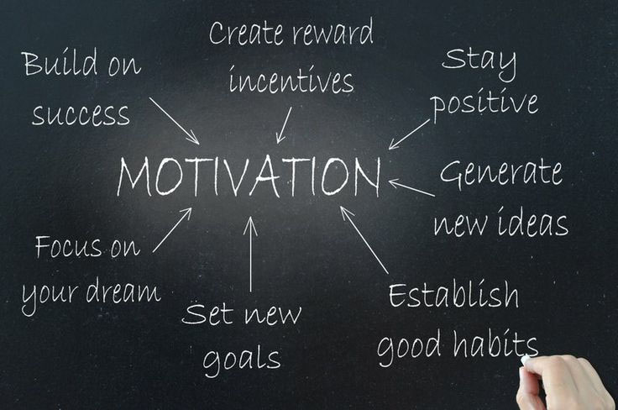
#4 Motivation - This is the second biggest barrier that was reported by employers, and the one with the most diversity of definition, therefore the hardest for which to identify a ready source of training. Many employers talked about their sense that job seekers lack the most basic responsibilities of workers; getting up on time every day, understanding that hard work pays off, knowing that while a car that won’t start is a problem, it’s not the employer’s problem.
A man who represents his family’s business, run by himself and his three brothers, summed it up this way: “When my brothers and I were little kids, our dad taught us that this business was our future. We understood even at a young age that how hard we worked on Saturday or after school would affect the quality of our lives down the road. Today, I have employees that have been working for me for 20 plus years. Not one of them is capable of taking over the business. The family business will close or be sold to an outsider. It’s really sad.”
Employers talked of young people who were incapable of passing a drug test, not because they were addicts, but because they didn’t understand that 30, 60 or even 90 days of clean time, a drop in life’s bucket, would open doors into great jobs. “They have no understanding that work takes time, it’s not about instant gratification.” “No one values the bigger picture, how they fit into that, and that it takes time.” Behaviors that led to a loss of driver’s license, bad credit, unstable housing, or not making it through a probationary period all contribute to a labor force that is incapable of keeping a job, even a good job. So many employers spoke of being willing to train employees to do what they needed them to do, if they would just show up ready to learn and to value the work beyond the paycheck.
There is a “hidden” component to motivation that may not be well understood by the employer around work site culture. Many people between the ages of 18-30 have very little work experience, paid or volunteer. The job site itself can be a very hard environment to navigate. It can be codified, hierarchical, clique-y, and often unfriendly. Job seekers who seem to do well during the initial training period when they are shadowing an older employee, for example, may find themselves not able to transition back into the environment alone when that relationship ends. Not feeling able to ask good questions can lead to making mistakes that may show up in an employee’s decision not to return to the job, especially after receiving a paycheck. This can look like, “they are just working for the next check” to an employer, when in fact the issues were much deeper.
The other barrier that was identified through the planning process is the one that exists at the community level and is systemic. The Collaborative found that while there were many services, the services themselves and the people who deliver them to the job seeker were not known across agency sectors. Access to Employment will strive to create a “hot” referral network where by job seekers needing services outside the scope of either the A2E program or Access’s program capacity will be assisted in as few steps as possible and with the greatest level of one-to-one care as possible. An example of this type of case management could be as simple as making a single call to a transportation provider to arrange pick up for work purposes or a more complicated process of locating the service, then identifying the staff member who speaks the needed language, providing the transportation and the follow up. Over time, A2E hopes to create a coordinated network of services, providers, specialists and employers who are part of the “hot” referral network and to make that network available across agencies, sectors, educational and health providers.

Training

The Access to Employment Training program aims to break down the identified barriers and close some of the gaps. Job seekers enrolled in the A2E training program will be required to participate in a multi-week (duration to be developed by the A2E program coordinator) curriculum that provides training in:
- Financial Coaching- This will be provided thru a partnership with existing programs such as the United Way’s one-on-one budget mentoring program. Financial Literacy is defined by A2E as the ability to reach a goal of financial stability through the process of learning management skills.

- Microsoft Office and other related computer training – A2E will look to provide this by utilizing the rich internship program that the Access Agency has in place.

- PEP training – People Empowering People (or an equivalent empowerment program not yet identified) is a proven program with a curriculum developed by the University of Connecticut’s Cooperative Extension program. PEP strives to instill a sense of value, civic connectedness and personal capacity and empowerment to its students. This multi-week training culminates with a community project.
- Transportation assistance – Initially A2E will partner with existing ride services in the greater Willimantic community like Curtin and Ace taxis services and the WRTD bus system to provide reliable transportation to and from work. Job seekers who complete the A2E training program and secure employment will be give EBT swipe cards with a fixed amount on the card that equals a daily stipend to be used for work related transportation.

- Case management – This will be provided by A2E family advocates and caseworkers, and will be the cornerstone of the program. Deep level, one-on-one case management will follow the jobseeker for one year.

Focused on supporting the job seeker where he or she is at, the case manager will be able to assist with even the most seemingly mundane barriers, such as alarm clocks and lunches, to the more complicated barriers around work site culture, understanding time sheets, stringing together transportation, and finding housing and child care to accommodate work. A2E job seekers and employers would enter into a multi-tiered agreement (to be developed by the A2E program coordinator) that has regular review periods built into it and opportunities for the employer to help A2E shape job seeker’s path. This further develops the A2E program by valuing both job seeker and employer experiences.
A2E will work to engage area employers for the program on a continual basis. This will be a very grassroots effort initially; “feet to the street” style of engagement. The A2E Program Director will need to enroll employers in the program and work one-on-one with each employer to develop MOU’s that support both the employer and the job seeker. While each MOU will be designed to fit the needs of the employer, basic points of contact should include regular (every six weeks) review of the relationships defined by the MOU. Ideally, employers who have enrolled in the A2E program will be able, at a minimum, to commit to looking at A2E graduates against other potential new hires. Lastly it will be important to identify a trusted employer in the community to be the “face of the program”. Willimantic and the surrounding towns are richly supported by family owned and operated business with deep roots and widespread connections to the wellbeing of the area. The goal would be to have an identified employer serve as a strong advocate for the program, through public speaking, local and social media post and other promotional opportunities. Ideally, peer pressure and smart business thinking would help other employers to want to join the A2E program.

Case Managers will be involved in all aspects of the job seeker’s training and employment period, assisting with classes and community projects. Job seekers who are identified as not really ready to enter the work force may be placed in volunteer positions for a period of time to help them develop work-related skills and internal motivation. Others may be directed to partner organizations that may be better suited to work with the individual. The MOU, case management that supports the job seeker and the employer, transportation and other training in combination, will help to ensure a successful employment/program/employer relationship.

Access to Employment - Future Growth and Sustainability

Future Growth

In its infancy, A2E will be a training program with 10 jobseekers and two industry-specific sectors of employment. The goal will be to expand the program so that multiple sectors are included in the training opportunities and a diverse set of options are developed for how A2E supports employment in the Greater Windham/Tolland counties. Examples of opportunities for future growth are:
Peer mentoring – A2E job seekers who have been successfully enrolled in the program for a period of time (to be determined by the program coordinator) will be paired with newly enrolled job seekers in a peer mentoring capacity. This one-to-one relationship would be an opportunity for new job seekers to develop a support system outside of the A2E program. As the program evolves and grows, “graduates” could be utilized as teachers of modules in the A2E training program, ambassadors to help A2E recruit new job seekers, and strong examples to employers, showcasing the success of the A2E graduate.
Jobs creation – A2E, in partnership with the Access Community Action Agency, would like to be able to create jobs through business development. The development would be tied to jobs that help further the mission of the Access Agency and reduce gaps and barriers to successful employment.
One idea is a transportation service that is modeled after today’s Uber service. Drivers would be trained thru the A2E program; the very existence of the service not only would create jobs, but also closes a gap identified by the A2E collaborative. Further development of a service garage with cars donated by citizens could create additional jobs and involve the local community in its own economy and wellbeing. With A2E branding and logo designs printed on the sides of the cars, local people can see their “donations” driving around the community and feel good about their contributions. This is only one of several job creations programs currently being developed by A2E and Access Agency.
Business Incubation Services – Currently Access occupies a building that has the capacity to provide space for a business incubation center. A2E and its various components could be located in the business development center. This would give existing programs like Women Inspired much needed affordable office space, infrastructure, professional assistance and support for its entrepreneurs to incubate their businesses.
Partnerships – Many exciting employment programs currently exist in the Willimantic area. Some of these are designed for incumbent job seekers and others are for new hires. One such program is ECO or Early College Opportunity and it involves students at both Windham High (WHS) and New London’s STEM academy. Students graduating from the WHS-ECO program would qualify for services that are offered by A2E. While these students will be highly trained in their manufacturing trades, they could be lacking in other areas that create barriers to their success, despite having completed a very rigorous educational program. A2E would like to partner with WHS-ECO to track the first cohort of graduates in an attempt to help successfully launch these students and future wage earners/community contributors. Other employment programs that A2E could partner with in the future are Platform to Employment, Serve Here Ct and Year-Up. Each of these is a distinctly different program and how the partnership would work will be up to the program director to develop and maintain.
Piloting open hire practices – Greyston Bakery in Yonkers, NY, is one of the country’s leading open hire businesses. Started in the early 1970’s, the bakery hires anyone, regardless of background, who fills out an application. Over the many years Greyston has grown to be more than a for-profit business making brownies that show up in Ben and Jerry’s ice cream. Today they also have a nonprofit side that has created housing, healthcare and childcare for its employees, thus eliminating many of the barriers that often accompany job seekers with criminal records, bad credit, and an inability to obtain a driver’s license. Much of their success lies in their apprenticeship program. This is a nine-month requirement for permanent employment that serves to develop employees who understand not just Greyston’s culture, but also what it means to be a valuable employee. Any employee who is able to finish the Greyston apprenticeship does so with the ability to carry much of that training to other work environments. By developing this open hire model and apprenticeship program, Greyston has transformed the neighborhood where it is located and trained many hundreds of people who previously were unemployed and unemployable and are now successfully, gainfully employed and supporting themselves and families.
A2E can use its own business development initiatives to hire people under its own open hire policy (to be developed by the program director.) These people will in turn find work in other industry sectors, spreading the success of the open hire model. A2E’s program director will develop the capacity to recruit employers who are interested in this model, providing training for them and their existing staff, as well as support for the A2E job seekers via case management.
Wage assistance – depended on funding. With funding, A2E could assist employers with a limited amount of wage assistance to job seekers in the program. This could be a significant relationship builder for the program, as well as providing a small bit of insurance to the employer.
Long term planning for removal of barriers – Access to Employment recognizes that barriers exist beyond those out lined in this plan. Affordable housing, childcare, healthcare, and low wage employment are some of them. Initially, A2E will address these barriers through its partnerships in the community. It is possible that over time and with the development of new businesses via the Access Agency, some of these barriers can be removed.

Sustainability

Sustainability can be defined by both the success of the program; its design, partnerships and execution as well as its financial support. In order for A2E to be successful and therefor sustainable, a plan for what happens when the job seekers doesn’t get or keep a job should be addressed as well as future financial support.
Current ideas for job seeker success include:
Reenrollment into the program – how many times can A2E support a job seeker? Is there going to be training beyond the initial should someone not be able to sustain meaningful work? How much resource will be spent on any one job seeker?
Expansion of A2E services – while volunteerism is a way to help job seekers ease in to paid work, there may need to be a greater emphasis on “nontraditional” ways of helping A2E job seekers find their way to paid employment.
Development of the A2E employee base – continual enrollment of employers into the program will be important so that job seekers who are unique in their employment needs can be matched with meaningful work. This can also be accomplished by helping job seekers to start business, or by giving them employment in an A2E based business that utilizes the open hire model. And, helping existing business to give the open hire model a try could also open up potential employment opportunities for the harder to place job seeker.

Financial sustainability:
Currently, the A2E plan is funded by a joint partnership that includes the United Way of Central and Northeastern Connecticut, Access Community Action Agency, First Niagara Foundation, Savings Institute Foundation, Liberty Bank Foundation and Charter Oak Credit Union Foundation. Internships with area educational programs and Access Agency current staff and resources are also being considered as financial supports to the program.
A program of the size and scope envisioned by the collaborative (budget appendix) cannot function or evolve solely on partnerships, and therefore will need to pursue financial sustainability. Currently, grant requests to the United Way, the Ossen Family Foundation, the Community Foundation of Eastern CT and DECD are being developed. Future grant requests to the federal government will be considered when A2E has grown a bit and becomes eligible for federal level funding.
The A2E collaborative will need to consider its own future once the program is launched. Acting as an advisory collaborative, a combination of the two original entities, and the next iteration of the collaborative and advisory team could assist with pragmatic shape, employer development, business incubation and start up as well as fund raising and development. The two entities are stacked with professional people whose capacity to help grow Access to Employment into a very successful employment program, unique to the region, is very impressive. A simple meeting schedule of four times a year and the continuation of regular communication from the program director to the group is a recommended consideration.

Closing Remarks

It has been said that every region in Connecticut sees itself as unique. The northeast corner is no exception. The question then becomes, what is it about a region that makes it so? For Windham and Tolland Counties, it could be the large tracts of state forest, the historic homes and villages, and the proliferation of small farms and farmer’s markets, along with easy commutes to Boston, Providence and the shore. Or maybe it’s high unemployment, a lack of sector-based industry, and very little transportation infrastructure, coupled with generational poverty and illiteracy in two languages. Access to Employment would like to think it’s the opportunities that exist in healthcare, manufacturing, food service and finance that make this region a unique opportunity for growth in employment. Partnerships between private businesses, educational institutions, workforce development boards and social service agencies combine to paint an encouraging future for the region. Couple these existing entities with new, emerging initiatives like Serve Here Ct, WHS-ECO and Gates University along with older established programs like Platform to Employment and services such as those at the American Jobs Center and EASTCONN and an optimistic landscape emerges. The addition of Access to Employment and the unique training and case management that will make up the core of this program will serve to strengthen the services to job seekers in the region in way that does not yet exist. What makes the north east corner unique is that it is made up of services and education and programs and businesses and most importantly people who have decide to put down roots, commit to their communities and give their time, energy, and support to where they live.

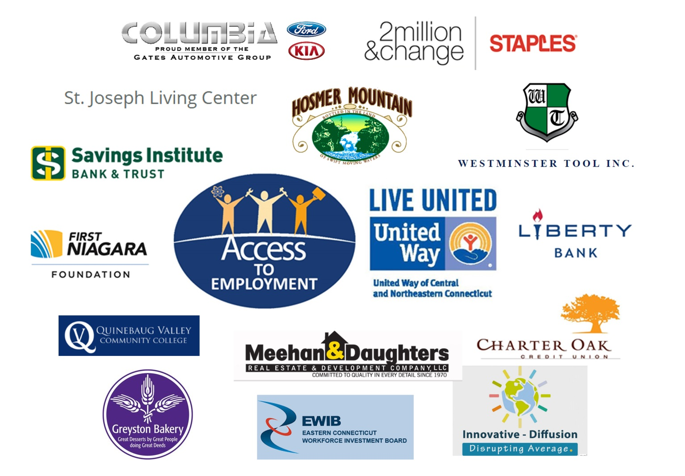
Thank you to the many who have contributed to this community employment plan.

